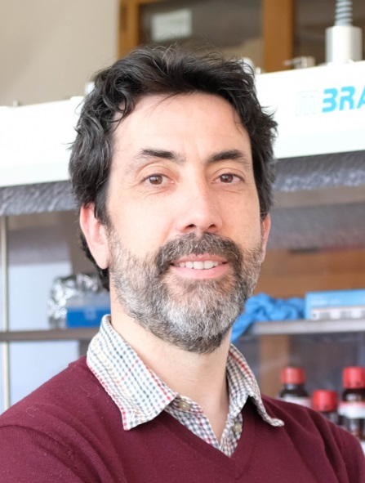
Sylvain Chambon (46 years old) is CNRS researcher at the IMS laboratory, University of Bordeaux (France). He completed his PhD at the University of Clermont-Ferrand (France) in 2006 under the supervision of Prof. Dr. Jean-Luc Gardette, Dr. Agnès Rivaton and Dr. Muriel Firon. During those years, he focused on the elucidation of the degradation mechanisms in active layers used for organic solar cells (OSC). He continued on the organic photovoltaic field in University of Hasselt (Belgium) as a post-doctoral fellow where he worked on solid-state NMR to investigate the morphology of organic active layers in OSC. After these years, he joined the CNRS in 2011 at the IMS laboratory with a main activity dedicated to the degradation mechanisms and stability of organic photovoltaics (OPV). During those years at IMS, he aimed at correlating the device performances to physico-chemical modifications upon ageing as well as developing solutions for increasing the lifetime of OPV devices. In March 2020, he moved to LIMMS, a CNRS international research laboratory at the University of Tokyo (IRL 2820) to develop a project dedicated to reducing the environmental impact of organic photovoltaics. In particular, he worked on the development of water-based colloidal organic semiconductors nanoparticles dispersions to replace toxic solvents used in OPV technology. He moved back to IMS laboratory in September 2022 to continue and extend this project towards reducing the environmental impact of PV technologies. He coordinated several research projects: ANR projects IN-STEP (2014 -2017) dedicated to stability of organic photovoltaic devices and WATER-PV (2020 – 2024) dedicated to environmentally friendly processes for OPV, and obtained recently the project BioFlexPV (2024 – 2029) in the framework of PEPR TASE. In addition, he has been involved in several ANR project dedicated to photovoltaics: CEPHORCAS, HELIOS for OPV, HYPERSOL for perovskite PV and ORGANIST for organic/silicon 3-terminals tandem devices.

